**Name_________________________Date______________Period_____**

**Biology Fall Semester Final Review**

1. What are the steps to the scientific method? (Six Great Farmers Plant All Day)
2. What is the Independent Variable? On a graph, on which axis do you find the independent varable?
3. What is the Dependent Variable? On a graph, on which axis to you find the dependent variable?
4. What is the control and why is it important in the lab design?
5. Squidward’s Symphony Squidward loves playing his clarinet and believes it attracts more jellyfish than any other instrument he has played. In order to test his hypothesis, Squidward played a song on his clarinet for a total of 5 minutes and counted the number of jellyfish he saw in his front yard. He played the song a total of 3 times on his clarinet and repeated the experiment using a flute and a guitar. He also recorded the number of jellyfish he observed when he was not playing an instrument. The results are shown in the chart.

**Number of Jellyfish/Instrument**

|  |  |  |  |  |
| --- | --- | --- | --- | --- |
| **Trial** | **No Music** | **Clarinet** | **Flute** | **Guitar** |
| 1 | 5 | 15 | 5 | 12 |
| 2 | 3 | 10 | 8 | 18 |
| 3 | 2 | 12 | 9 | 7 |

1. What should his hypothesis be?
2. What is the independent variable?
3. What is the dependent variable?
4. What is the control?
5. What should Squidward’s conclusion be?
6. Are the results reliable? Why or why not?

Biomolecules

|  |  |  |  |  |
| --- | --- | --- | --- | --- |
|  | **Carbohydrates** | **Lipids** | **Proteins** | **Nucleic Acids** |
| **Function** |  |  |  |  |
| **Monomer** |  |  |  |  |
| **Structure** |  |  |  |  |
| **Examples** |  |  |  |  |

What is a catalyst?

What is the function of an enzyme?

How is an enzyme a catalyst?

What does an enzyme end in?

1. Which of the following macromolecules are a prominent part of animal tissues that function in insulation, helping animals conserve heat?

A. Nucleic acids

B. Proteins

C. Carbohydrates

D. Lipids

1. Which best describes how enzymes function in the body?

A. Enzymes are converted in products by the reaction they catalyze.

B. Enzymes lower the activation energy of reactions.

C. One enzyme can catalyze many different reactions.

D. An enzyme is used once and then destroyed by the cell

What does the Cell Theory State?

Prokaryote vs Eukaryote Worksheet

Read the passage below. Then answer the questions that follow.

The first cells to appear on Earth were prokaryotic cells. A **prokaryote** is an organism made of a single prokaryotic cell. The earliest prokaryotes may have arisen more than 2.5 billion years ago. Bacteria are prokaryotes. They are very small cells with a simple structure. Prokaryotes do not have a **nucleus.** This means that their DNA is not enclosed in a membrane inside the cell. Instead, prokaryotes have a single loop of DNA that floats in the cell’s **cytoplasm.** Protein-making bodies called **ribosomes** also form part of the cytoplasm. Like all cells, prokaryotes have a **cell membrane.** All prokaryotes also have a cell wall surrounding the cell membrane. The cell wall helps provide support and protection for the cell. Some prokaryotes are enclosed by an additional layer. This layer is called the capsule. The capsule has a sticky surface area, so it allows prokaryotes to cling to surfaces, such as your skin and your teeth.

Eukaryotic cells are more complex than prokaryotic cells. They all have a cell membrane, ribosomes, and DNA as prokaryotic cells do. However, the DNA of eukaryotic cells does not float freely in the cytoplasm. Instead, it is found in the nucleus, an internal compartment bound by a cell membrane. The nucleus is one kind of organelle found in eukaryotic cells. **Organelles** are structures that perform specific functions. Most organelles are surrounded by a membrane. Some organelles have membranes that form channels which help transport substances from one part of the cell to another part of the cell.

**Eukaryotes** are organisms made of one or more eukaryotic cells. The earliest eukaryotes, like the first prokaryotes, were single-celled organisms. They arose about 1 billion years later than the earliest prokaryotes. Later, multicellular eukaryotes arose. Every type of multicellular organism that exists is made up of eukaryotic cells.

Read each question, and write your answer in the space provided.

1. What is a **prokaryote**, and when did prokaryotes arise?

Prokaryote vs. Eukaryote Worksheet continued

2. Describe **three** main features inside a **prokaryotic** cell.

3. Describe the **structures** that form the outside of a **prokaryotic** **cell**. Tell whether each structure is common to **all** prokaryotes.

4. What is a **eukaryote**, and when did eukaryotes first arise?

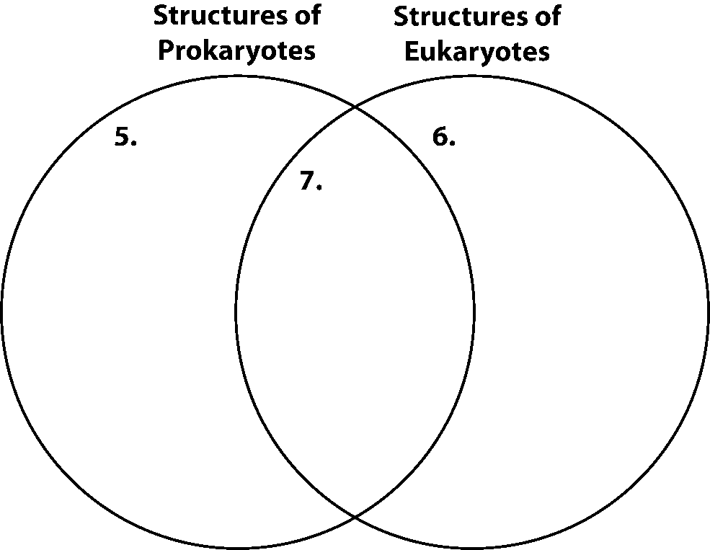skill: Organizing Information

Fill in the Venn diagram to compare and contrast the structure of prokaryotic   
and eukaryotic cells.

In the space provided, write the letter of the phrase that best answers the question.

8. From which type of cells did **multicellular** organisms arise?

a. prokaryotic cells b. prokaryotic cells with a capsule

c. eukaryotic cells d. both prokaryotic and eukaryotic cells

**Cell Organelles Worksheet**

Complete the following table by writing the name of the cell part or organelle in the right hand column that matches the structure/function in the left hand column. A cell part **may** be used more than once.

*Chloroplast(grana) Mitochondrion Plasma Membrane Golgi Apparatus Lysosome Cilia/Pili Flagellum Cell Wall Nucleus*

*Vacuole Microtubules/Microfilaments Smooth ER Cytoplasm Ribosome Vesicles Rough ER Cytoskeleton Chromatin*

|  |  |
| --- | --- |
| **Structure/Function** | **Cell Part** |
| 1. Stores material within the cell |  |
| 1. Closely stacked, flattened sacs (plants only) |  |
| 1. The sites of protein synthesis |  |
| 1. Transports materials within the cell |  |
| 1. The region inside the cell except for the nucleus |  |
| 1. Organelle that manages or controls all the cell functions in a eukaryotic cell |  |
| 1. Contains chlorophyll, a green pigment that traps energy from sunlight and gives plants their green color |  |
| 1. Digests excess or worn-out cell parts, food particles and invading viruses or bacteria |  |
| 1. Small bumps located on portions of the endoplasmic reticulum |  |
| 1. Provides temporary storage of food, enzymes and waste products |  |
| 1. Firm, protective structure that gives the cell its shape in plants, fungi, most bacteria and some protests |  |
| 1. Produces a usable form of energy for the cell |  |
| 1. Packages proteins for transport out of the cell |  |
| 1. Associated with the production and metabolism of fats and steroid hormones. It is 'smooth' because it is not studded with ribosomes |  |
| 1. There are ribosomes attached to the surface, giving it a bumpy or 'rough' appearance. It is involved in protein synthesis |  |
| 1. The membrane surrounding the cell |  |

Put a check in the appropriate column(s) to indicate whether the following organelles are found in plant cells, animal cells, bacterial cells or all.

| **Organelle** | **Plant Cells** | **Animal Cells** | **Bacterial Cells** |
| --- | --- | --- | --- |
| Cell Wall |  |  |  |
| Vesicle |  |  |  |
| Chloroplast |  |  |  |
| Chromatin |  |  |  |
| Cytoplasm |  |  |  |
| Cytoskeleton |  |  |  |
| Endoplasmic reticulum |  |  |  |
| Golgi apparatus |  |  |  |
| Lysosome |  |  |  |
| Mitochondria |  |  |  |
| Nucleolus |  |  |  |
| Nucleus |  |  |  |
| Plasma membrane |  |  |  |
| Central vacuole |  |  |  |
| Ribosome |  |  |  |
| Vacuole |  |  |  |

Explain the endosymbiotic theory? How is the mitochondria and chloroplast involved.

**Complete the table by checking the correct column for each statement:**

|  |  |  |  |
| --- | --- | --- | --- |
| Statement | Isotonic solution | Hypotonic solution | Hypertonic solution |
| Causes a cell to swell |  |  |  |
| Doesn’t change the shape of a cell |  |  |  |
| Causes osmosis |  |  |  |
| Causes a cell to shrink |  |  |  |

Match the term with its correct description:

1. energy e. active transport
2. facilitated diffusion f. exocytosis
3. endocytosis g. protein pump
4. passive transport h. channel protein

_______ Transport protein that provides a tube-like opening in the plasma membrane through which particles can diffuse

_______ Is used during active transport but not passive transport

________ Process by which a cell takes in material by forming a vacuole around it

________ Particle movement from an area of higher concentration to an area of lower concentration

_______ Process by which a cell expels wastes from a vacuole

________ A form of passive transport that uses transport proteins

___­___ Particle movement from an area of lower concentration to an area of higher concentration

________ Protein that must change shape in order to transport particles

**Match the term with its correct description:**

1. transport protein d. passive transport g. osmosis
2. exocytosis e. endocytosis h. diffusion
3. active transport f. equilibrium

_____ The diffusion of water through a cell membrane

_____ The movement of substances through the cell membrane without the use of cellular energy

_____ Used to help substances enter or exit the cell membrane

_____ When energy is required to move materials through a cell membrane

_____ When the molecules of one substance are spread evenly throughout another substance to become balanced

_____ A vacuole membrane fuses (becomes a part of) the cell membrane and the contents are released

_____ The cell membrane forms around another substance, for example, how the amoeba gets its food

____ When molecules move from areas of high concentration to areas of low concentration

Osmosis is the diffusion of water from an area of high concentration to an area of low concentration. Only water moves in osmosis! The diagrams below show the concentration of water and salt inside the cell and the concentration of water and salt surrounding the cell. Complete the sentences below by comparing the concentration of the water inside the cell and the concentration outside the cell.

1.

1. What solution type is this
2. How will the water flow
3. What will happen to the cell

95% NaCl

5% H2O

5% NaCl

95% H2O

2.

5% NaCl

95% H2O

5% NaCl

95% H2O

1. What solution type is this
2. How will the water flow
3. What will happen to the cell
4. What solution type is this
5. How will the water flow
6. What will happen to the cell

3.



5% NaCl

95% H2O

95% NaCl

5% H2O